Task 1 — Building a RESTful API
Tech Used: Node.js, Express.js, MongoDB

Step 1 — Project Setup
I initialized a Node.js project using npm init -y which created a package.json file. This file acts as the project's identity card storing the project name, version and all dependencies.
Command used:
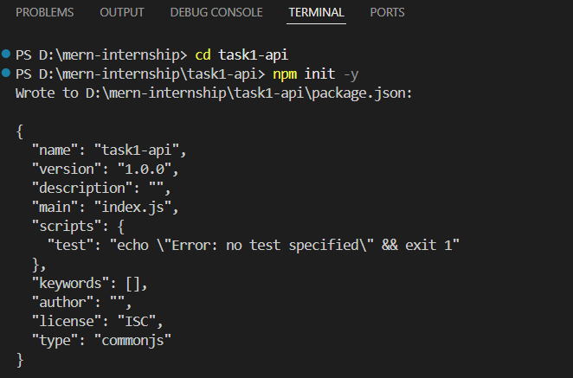
npm init -y

Step 2 — First Node.js Program
I created server.js and ran a basic JavaScript program using Node.js without a browser.
Command used:
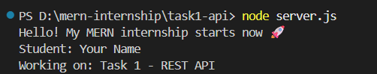
node server.js
Step 3 — First HTTP Server
I built a basic HTTP server using Node.js built-in http module. The server listens on port 5000 and responds with a message when accessed from the browser.
Key concepts learned:
- req = request from browser
- res = response we send back
- localhost:5000 = our computer at door number 5000
- HTTP 200 = success status code
Command used:
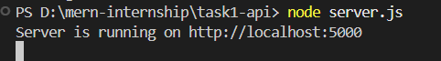
node server.js
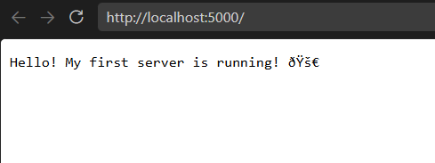

Step 4 — Setting Up Express.js
Plain Node.js HTTP module becomes complex with multiple routes. Express.js is a framework built on Node.js that simplifies server creation and route management.
Installation:
npm install express
Key concepts learned:
- require('express') → imports the Express package
- app.get('/path') → handles GET requests on that path
- req → request from client (browser/Postman)
- res → response we send back
- app.listen(5000) → starts server on port 5000
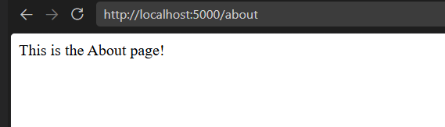
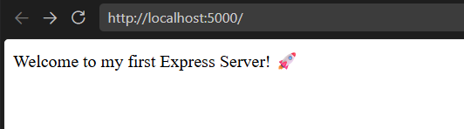
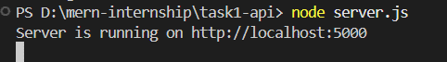
- express.json() → middleware to read JSON data

